INTRODUCTION TO ALDOL CONDENSATION

Aldol condensation is an important organic reaction in which two molecules of aldehyde or ketone, each containing at least one α-hydrogen atom, react in the presence of a dilute base or acid to form a β-hydroxy aldehyde (called aldol) or β-hydroxy ketone. Upon heating, this product undergoes dehydration to give an α,β-unsaturated aldehyde or ketone.

For example:
2 CH₃CHO → CH₃CH(OH)CH₂CHO → CH₃CH=CHCHO + H₂O

This reaction proceeds via the formation of an enolate ion, which acts as a nucleophile and attacks another carbonyl group. Aldol condensation is widely used in organic synthesis to form new carbon–carbon bonds and to prepare complex molecules, perfumes, and pharmaceuticals

MECHANISM OF ALDOL CONDENSATION

The Aldol Condensation reaction takes place in two main steps — formation of the enolate ion and nucleophilic addition to another carbonyl compound.

Step 1: Formation of Enolate Ion
- In the presence of a dilute base (like NaOH), the α-hydrogen of an aldehyde or ketone is abstracted.
- This forms an enolate ion, which is resonance-stabilized.
Example (using acetaldehyde):
CH₃CHO + OH⁻ → CH₂⁻CHO + H₂O

Step 2: Nucleophilic Attack
- The enolate ion formed acts as a nucleophile and attacks the carbonyl carbon of another molecule of aldehyde or ketone.
- This produces a β-hydroxy aldehyde (aldol) intermediate.
CH₂⁻CHO + CH₃CHO → CH₃CH(OH)CH₂CHO

Step 3: Dehydration
- On heating, the β-hydroxy aldehyde loses a molecule of water to form an α,β-unsaturated aldehyde.
CH₃CH(OH)CH₂CHO → CH₃CH=CHCHO + H₂O

Overall Reaction
2 CH₃CHO → CH₃CH=CHCHO + H₂O
Mechanism

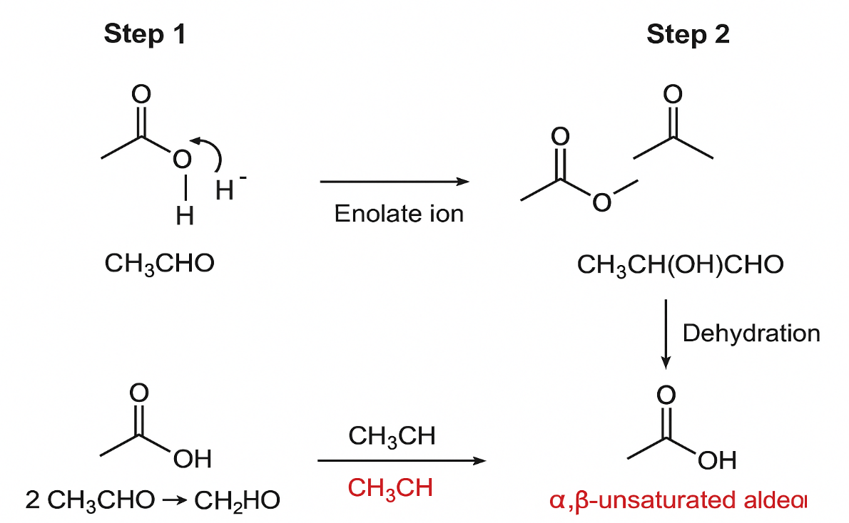

EXAMPLE OF ALDOL CONDENSATION REACTION

1. Acetaldehyde (Ethanal) Self-Condensation
Reaction:
2 CH₃CHO → CH₃CH(OH)CH₂CHO → CH₃CH=CHCHO + H₂O
Product: Crotonaldehyde (α,β-unsaturated aldehyde)
Explanation:
Two molecules of acetaldehyde react in the presence of dilute NaOH to form β-hydroxybutanal (aldol), which on heating dehydrates to give crotonaldehyde.

2. Acetone (Propanone) Self-Condensation
Reaction:
2 CH₃COCH₃ → CH₃COCH₂C(OH)(CH₃)₂ → CH₃COCH=CHCOCH₃ + H₂O
Product: Mesityl oxide (α,β-unsaturated ketone)
Explanation:
Two molecules of acetone condense in the presence of dilute alkali to form diacetone alcohol, which loses water upon heating to form mesityl oxide.

3. Cross Aldol Condensation (Between Aldehyde and Ketone)
Example: Acetaldehyde + Acetone
CH₃CHO + CH₃COCH₃ → CH₃CH(OH)CH₂COCH₃ → CH₃CH=CHCOCH₃ + H₂O
Product: 4-penten-2-one
Explanation:
In this reaction, acetaldehyde acts as the aldehyde component and acetone as the ketone, giving a mixed aldol condensation product.

4. Benzaldehyde and Acetone (Claisen–Schmidt Reaction)
Reaction:
C₆H₅CHO + CH₃COCH₃ → C₆H₅CH=CHCOCH₃ + H₂O
Product: Benzalacetone
Explanation:
Since benzaldehyde has no α-hydrogen, it reacts only with the enolate form of acetone. This reaction is a special case of aldol condensation called the Claisen–Schmidt condensation.

APPLICATION OF ALDOL CONDENSATION

Aldol condensation is one of the most important reactions in organic chemistry because it forms new carbon–carbon bonds. Here are its major applications:

1. Synthesis of Complex Organic Compounds
Aldol condensation is widely used to synthesize complex molecules such as alcohols, aldehydes, and ketones with longer carbon chains. It helps in building the carbon framework in many organic compounds.

2. Industrial and Pharmaceutical Uses
This reaction is used in the industrial preparation of fine chemicals, pharmaceutical intermediates, and perfume ingredients such as crotonaldehyde and cinnamaldehyde.

3. Polymer and Resin Production
Certain aldol products act as monomers in the synthesis of polymers and resins, useful in coatings, adhesives, and plastics.

4. Formation of α,β-Unsaturated Compounds
It provides an easy route to synthesize α,β-unsaturated aldehydes and ketones, which are key intermediates in many organic syntheses and addition reactions.

5. Biochemical Importance
Aldol-type reactions occur naturally in living organisms. For example, the Aldolase enzyme catalyzes a similar reaction in glycolysis, an essential biological pathway for energy production.

6. Preparation of Perfumes and Flavors
Many fragrance and flavor compounds such as benzalacetone and cinnamaldehyde are prepared through aldol condensation reactions.

CONCLUSION
Aldol condensation is a fundamental and versatile organic reaction that plays a key role in both laboratory and industrial chemistry. It involves the formation of new carbon–carbon bonds, leading to the synthesis of β-hydroxy aldehydes or ketones, which can further dehydrate to give α,β-unsaturated compounds.
This reaction not only demonstrates the reactivity of carbonyl compounds but also serves as a foundation for the synthesis of complex molecules used in pharmaceuticals, polymers, perfumes, and fine chemicals. Moreover, similar reactions occur naturally in biological systems, highlighting its universal importance.
In conclusion, Aldol Condensation is an essential tool in organic synthesis, bridging simple carbonyl compounds to more complex and useful organic molecules.

REFERENCES
1• NCERT Chemistry Textbook – Class XII, Part II, Chapter on Aldehydes, Ketones and Carboxylic Acids.
2 Morrison R.T. & Boyd, R.N., Organic Chemistry, 6th Edition – Prentice Hall.
3 Chemguide.co.uk – Online resource for understanding organic mechanisms.
4 Wikipedia – “Aldol reaction” and “Aldol condensation” articles for general overview and mechanisms
5 chatgpt and other ai

